Streamlining IT Procurement: Automating Standard Laptop Orders with Flow Designer
Project Abstract
Title: Streamlining IT Procurement: Automating Standard Laptop Orders with Flow Designer
Author/Role: IT Enterprise Architect / ServiceNow Developer
Automating standard laptop orders using ServiceNow Flow Designer eliminates manual bottlenecks, reduces fulfillment cycle times, and minimizes human error in IT procurement. The proposed solution leverages the Service Catalog for intake, routes approvals through Flow Designer, and integrates with vendor APIs to streamline procurement and asset tracking. You can read the full analysis at ServiceNow.
Context & Problem Statement
Traditional IT procurement workflows are often plagued by manual bottlenecks, fragmented communications, and high operational overhead. In many enterprise environments, provisioning a standard corporate laptop requires manual verification, back-and-forth email approvals, and manual data entry into vendor portals. This fragmented approach extends fulfillment Service Level Agreements (SLAs), increases the risk of human data-entry errors, and creates a visibility gap in initial hardware asset tracking.
Proposed Solution
This project introduces a "zero-touch" automated procurement pipeline engineered within the ServiceNow platform. By leveraging the Service Catalog for structured user intake, Flow Designer for low-code process orchestration, and IntegrationHub for outbound API connectivity, the solution replaces manual tasks with automated, end-to-end logic.
The workflow automatically captures user requirements, evaluates price thresholds to dynamically route manager and departmental approvals, pre-allocates hardware assets within the Configuration Management Database (CMDB), and triggers real-time POST requests to external vendor APIs (e.g., Dell, HP, CDW) to place orders instantly. Robust error-handling structures are built into the flow to capture API anomalies and seamlessly route exceptions to manual procurement queues, ensuring zero dropped orders.
Objective:
The objective of this project is to implement an automated workflow using Flow Designer to facilitate the procurement and configuration of standard laptops. By integrating automation into the process, the project aims to:
- Create a seamless experience for users requesting standard laptops by ensuring timely configuration.
- Reduce manual intervention and potential errors in the procurement process.
- Improve resource utilisation within the IT department by optimising task allocation.
- Enhance overall efficiency and productivity in IT procurement operations.
Problem Statement:
The current IT procurement process lacks efficiency and automation, resulting in delays and manual overhead, particularly in handling standard laptop orders. Requests for standard laptops often require configuration, but this step is prone to oversight or delay, leading to frustration among users and inefficient resource allocation within the IT department.

User Story:

As a member of the IT procurement team, I want a streamlined process for ordering standard laptops so that tasks are automatically generated and assigned to the hardware team for configuration. This will ensure that laptops are promptly configured upon arrival, reducing user wait times and minimising manual intervention.

Flow

Create a Flow to Create Catalog task to update the short description after Approval the service Request and it will be Assignment group to Hardware.

- Open service now.
- Click on All >> search for Flow Designer
- Click on Flow Designer under Process Automation.
- After opening Flow Designer Click on new and select Flow.
- Under Flow properties Give Flow Name as “ Standard laptop task”.
- Application should be Global.
- Select Run user as “ System user ” from that choice.
- Click on Submit.

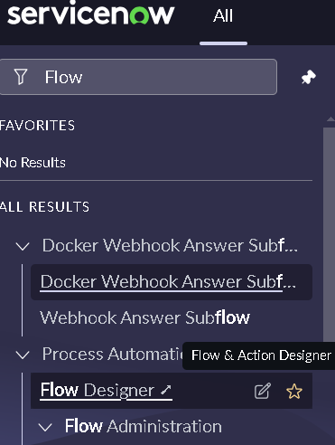
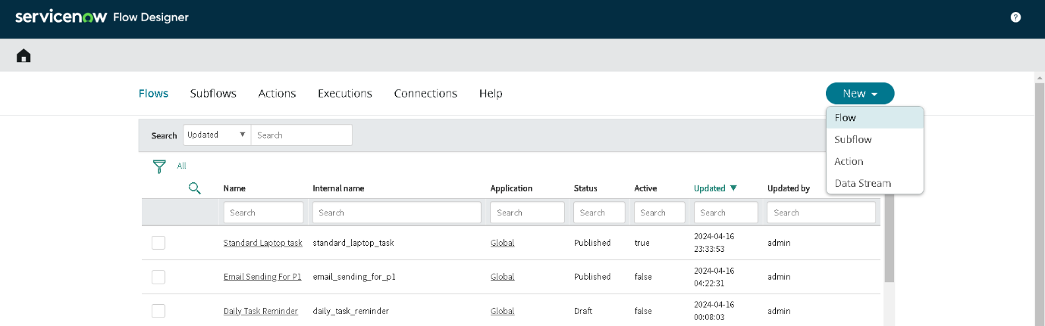

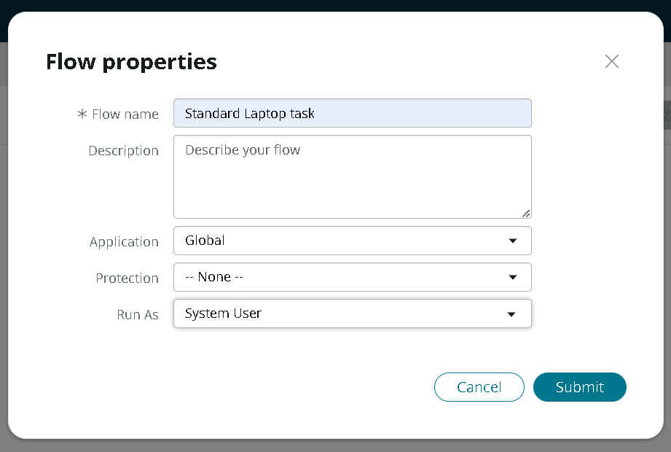

- Click on Add a trigger
- Select the trigger in that Search for “ Service Catalog ” and select that.
- After that click on Done.
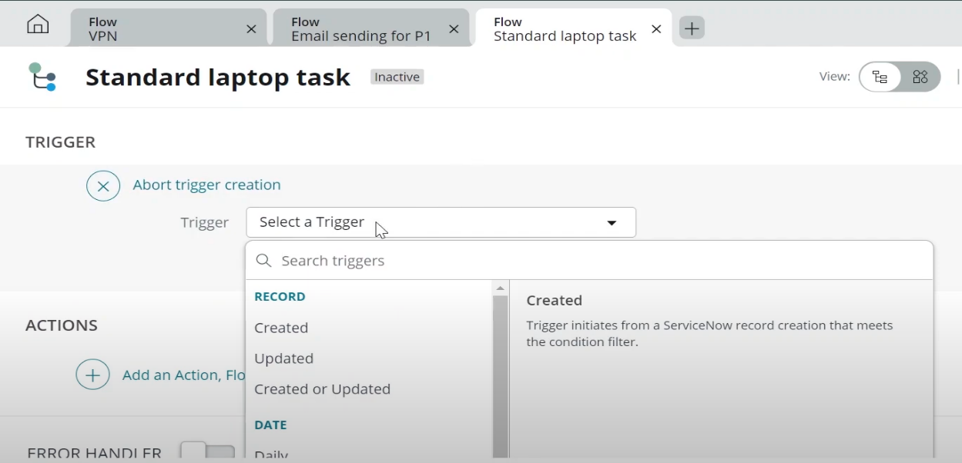

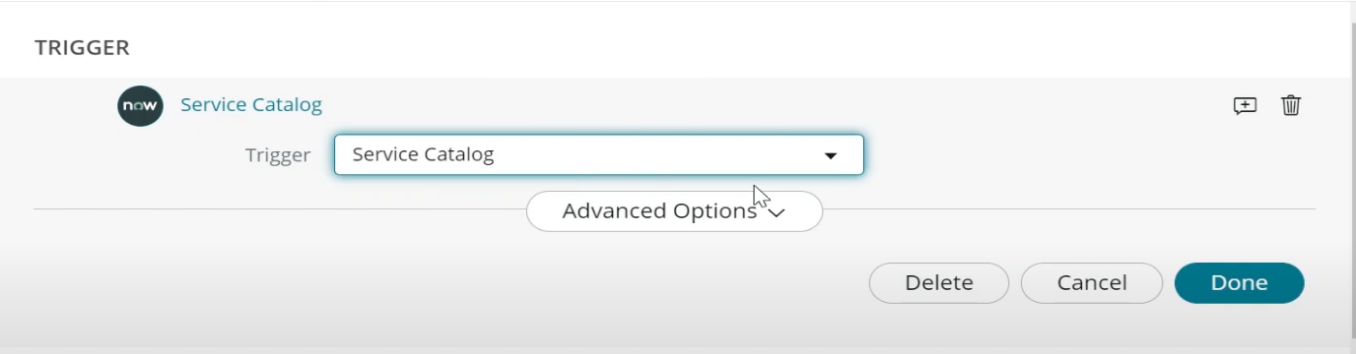

- Now under Actions.
- Click on Add an action.
- Select action in that search for “Ceate Catalog Task” and select that.
- Mention these in that action
- Action as Create Catalog Task
- Drag and drop the Requested Item Record in the Request item.
- Table will be auto populated as a Catalog Task.
- Mention the short description as “Laptop need to Configured”.
- Click on add field value
- Select description field and value as “Laptop need to Configured”.
- Select Assignment group field and value as “Hardware”.
- Select Approval field and value as “Approved”.
- Leave the remaining as default and click on Done.
- Click on save the Flow.
- And Click on Activate again click on Activate.
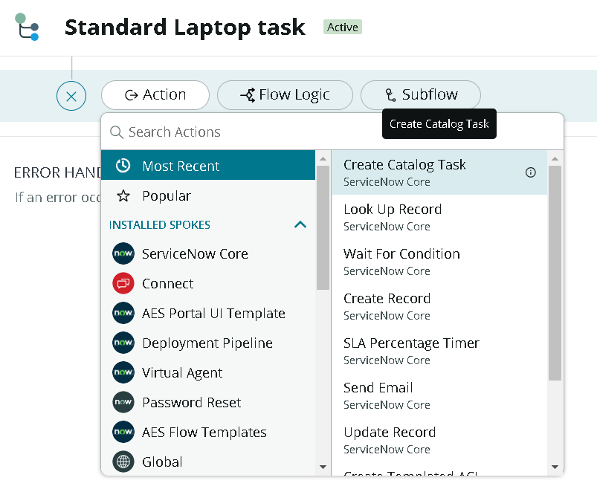

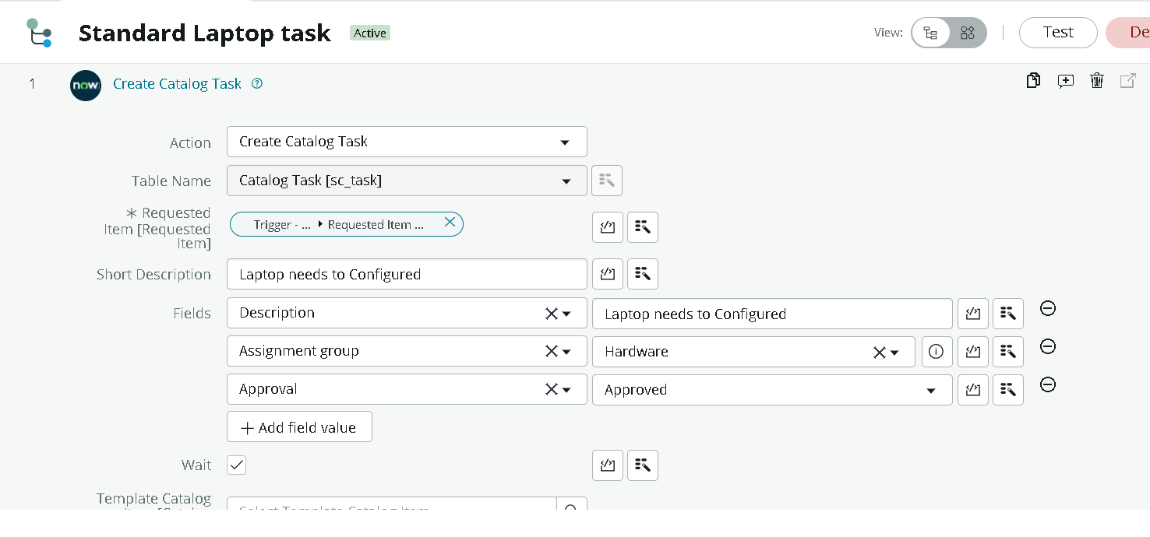

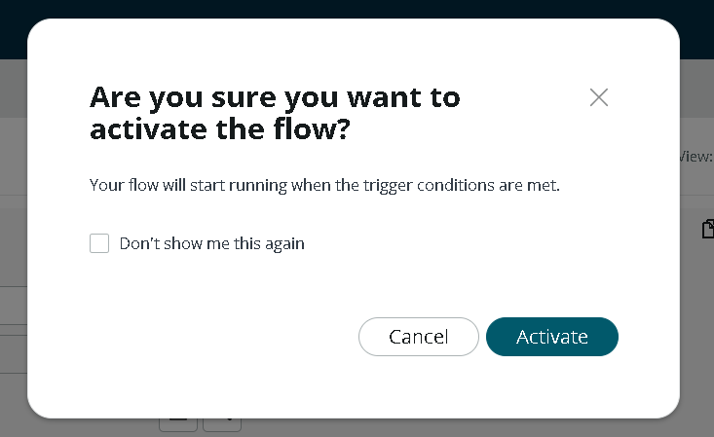

Flow assignment
Flow Assignment to Standard laptop service Catalog.

- Open ServiceNow.
- Click on all search for Maintain Items.
- Select Maintain Items.
- Under the name field search for Standard Laptop Select that record.
- Under that record select Process engine
- Remove the remaining automations and add Flow.
- Add the flow that was created with the name “Standard Laptop Task”.
- Click on the menu to save the record.

Conclusion

Creating automated workflows for catalog items in ServiceNow using Flow Designer is a foundational skill for every admin or developer. You save time, reduce manual errors, and deliver a seamless experience your users will appreciate. By working with templates and testing in your own PDI, you gain the confidence to roll out robust, production-ready automations. By automating the standard laptop procurement process with ServiceNow's Flow Designer, the project effectively addresses inefficiencies and reduces manual overhead. This streamlined workflow ensures timely configuration of laptops, minimizes user wait times, and enhances overall productivity within the IT department. The implementation of this automated solution not only optimizes resource allocation but also significantly improves the user experience by providing a seamless and efficient procurement process.

